Week 05
Problem Statement:
Write a program that prints a simple chessboard.
Input format:
The first line contains the number of inputs T.
The lines after that contain a different value for size of the chessboard
Output format:
Print a chessboard of dimensions size * size.
Print W for white spaces and B for black spaces.
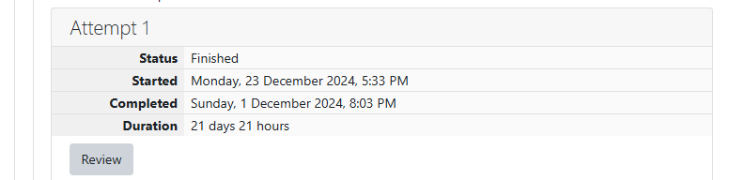
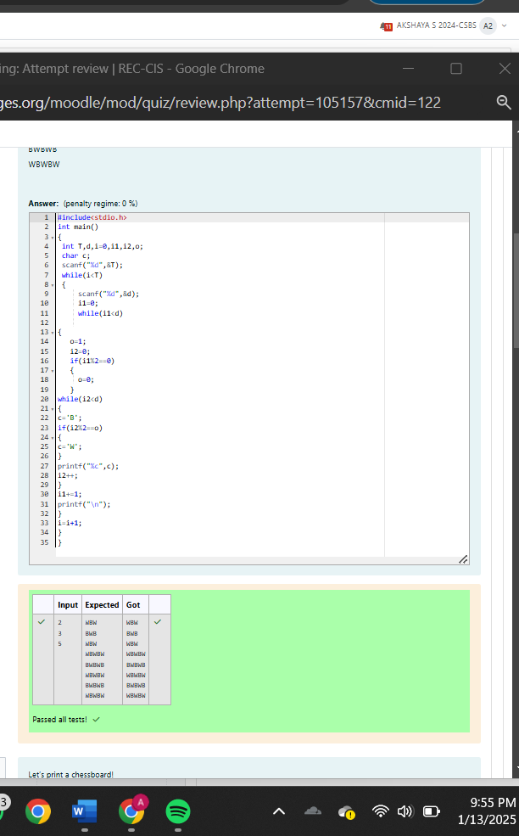

GE23131 - Programming Using
Print Our Own Chessboard
Problem Statement:
Let’s print a chessboard!
Write a program that takes input:
The first line contains T, the number of test cases
Each test case contains an integer N and also the starting character of the chessboard
Output Format
Print the chessboard as per the given examples
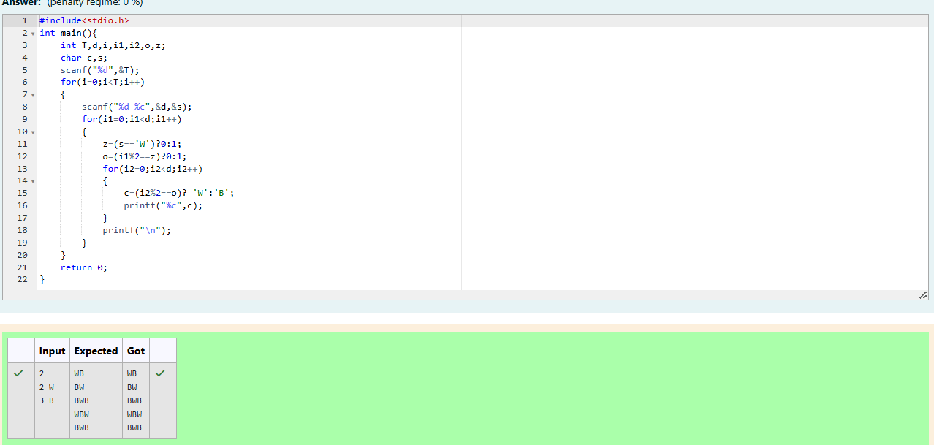
Problem Statement:
Decode the logic and print the Pattern that corresponds to given input.
If N= 3 then pattern will be:
10203010011012
**4050809
****607
If N= 4, then pattern will be:
1020304017018019020
**50607014015016
****809012013
******1001
Problem Statement:
The k-digit number N is an Armstrong number if and only if the k-th power of each digit
sums to N.
Given a positive integer N, return true if and only if it is an Armstrong number.
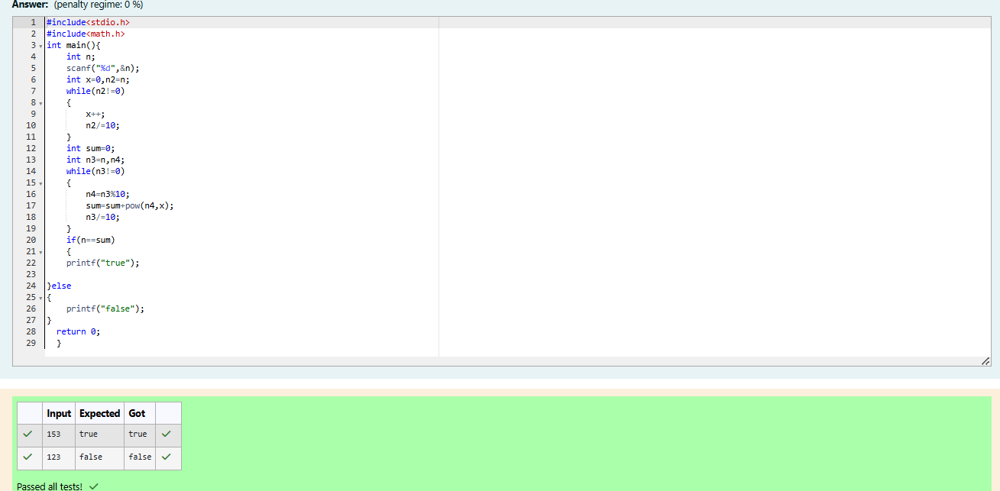
Problem Statement:
Take a number, reverse it and add it to the original number until the obtained number is
a palindrome.
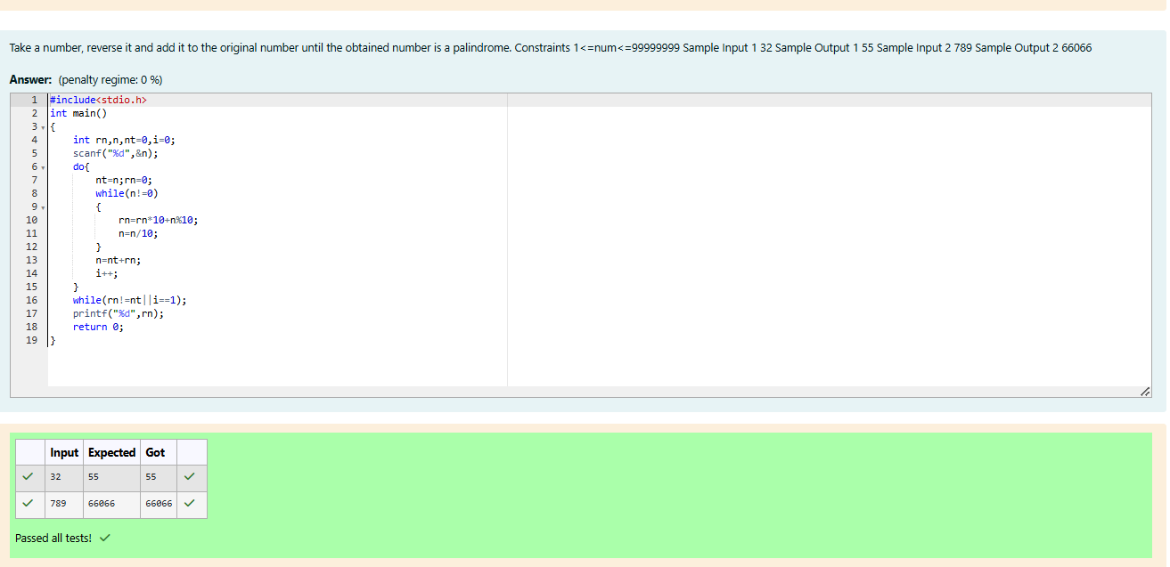
Problem Statement:
A number is considered lucky if it contains either 3 or 4 or 3 and 4 both in it. Write a
program to print the nth lucky number. Example, 1st lucky number is 3, and 2nd lucky
number is 4 and 3rd lucky number is 33 and 4th lucky number is 34 and so on. Note that
13, 40 etc., are not lucky as they have other numbers in it.
